**CCD Experiment – 6**

**Aim**: To Design a Sample and Hold Circuit in NI Multisim.

**Circuit Diagram:**

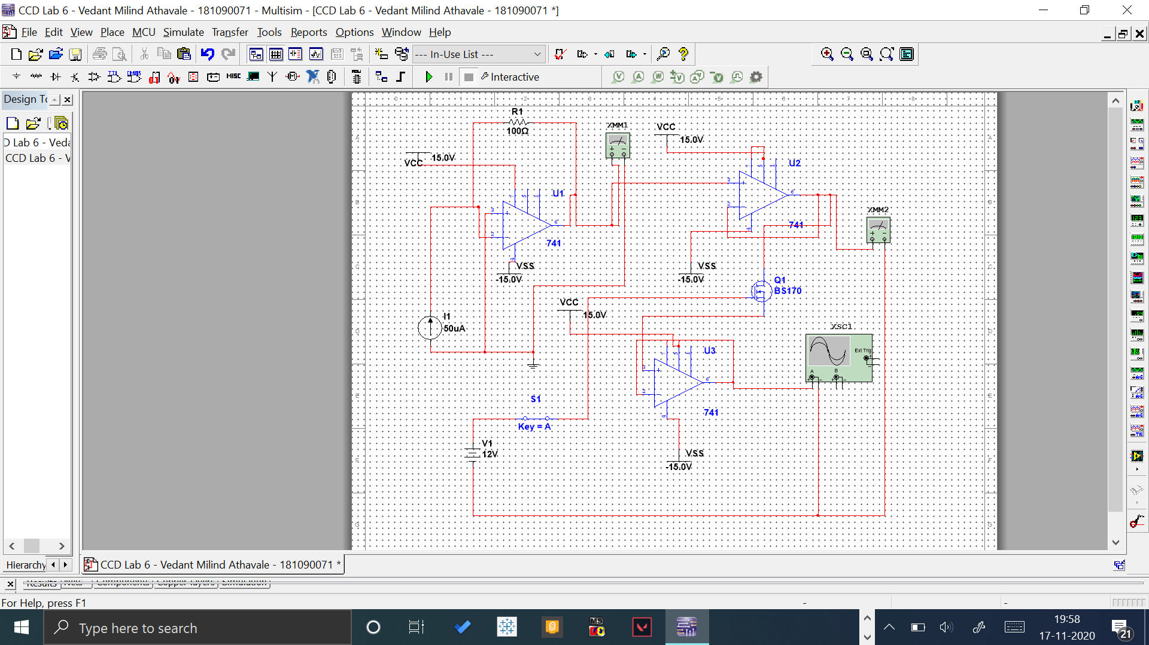

**Output**:

1. **When S1 key is open:**

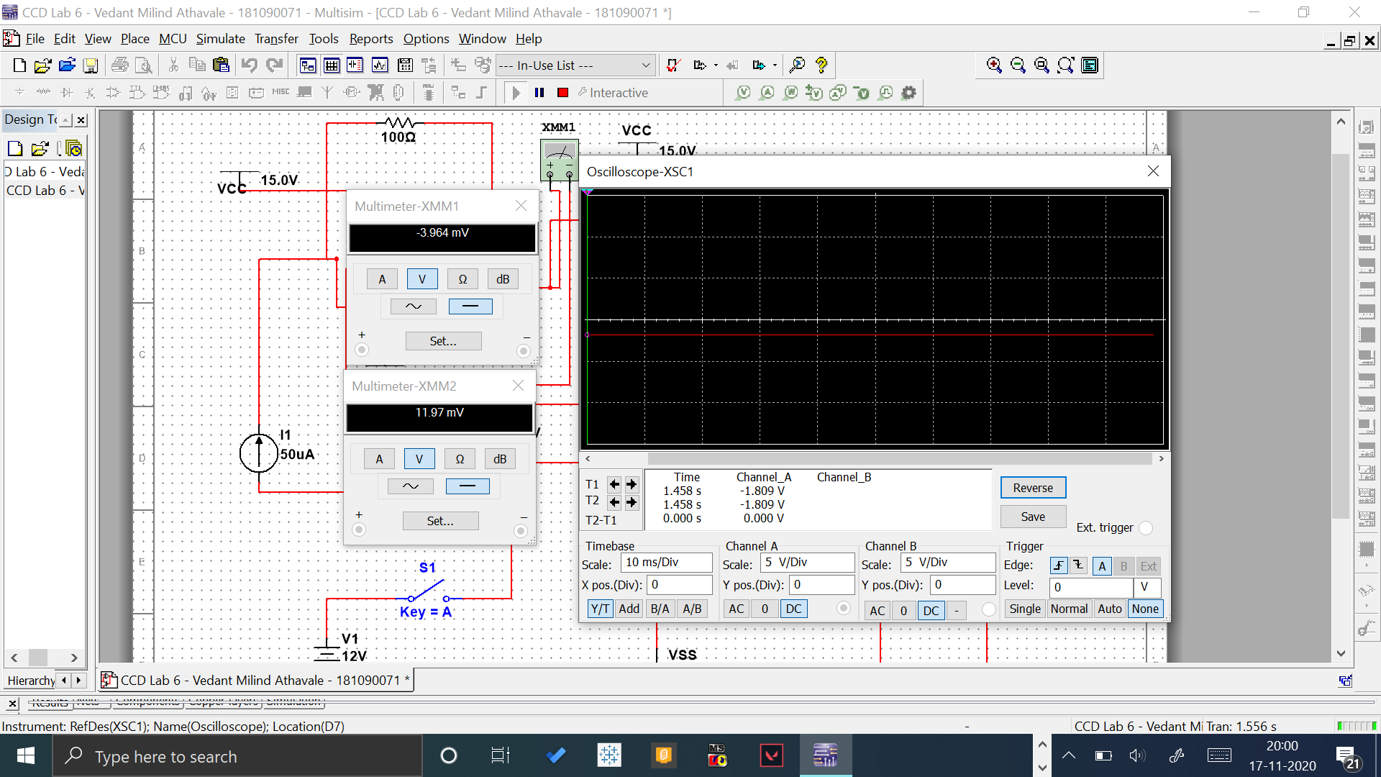

**When S1 key is closed: (With Reversed Background Color for better visuals of plot)**

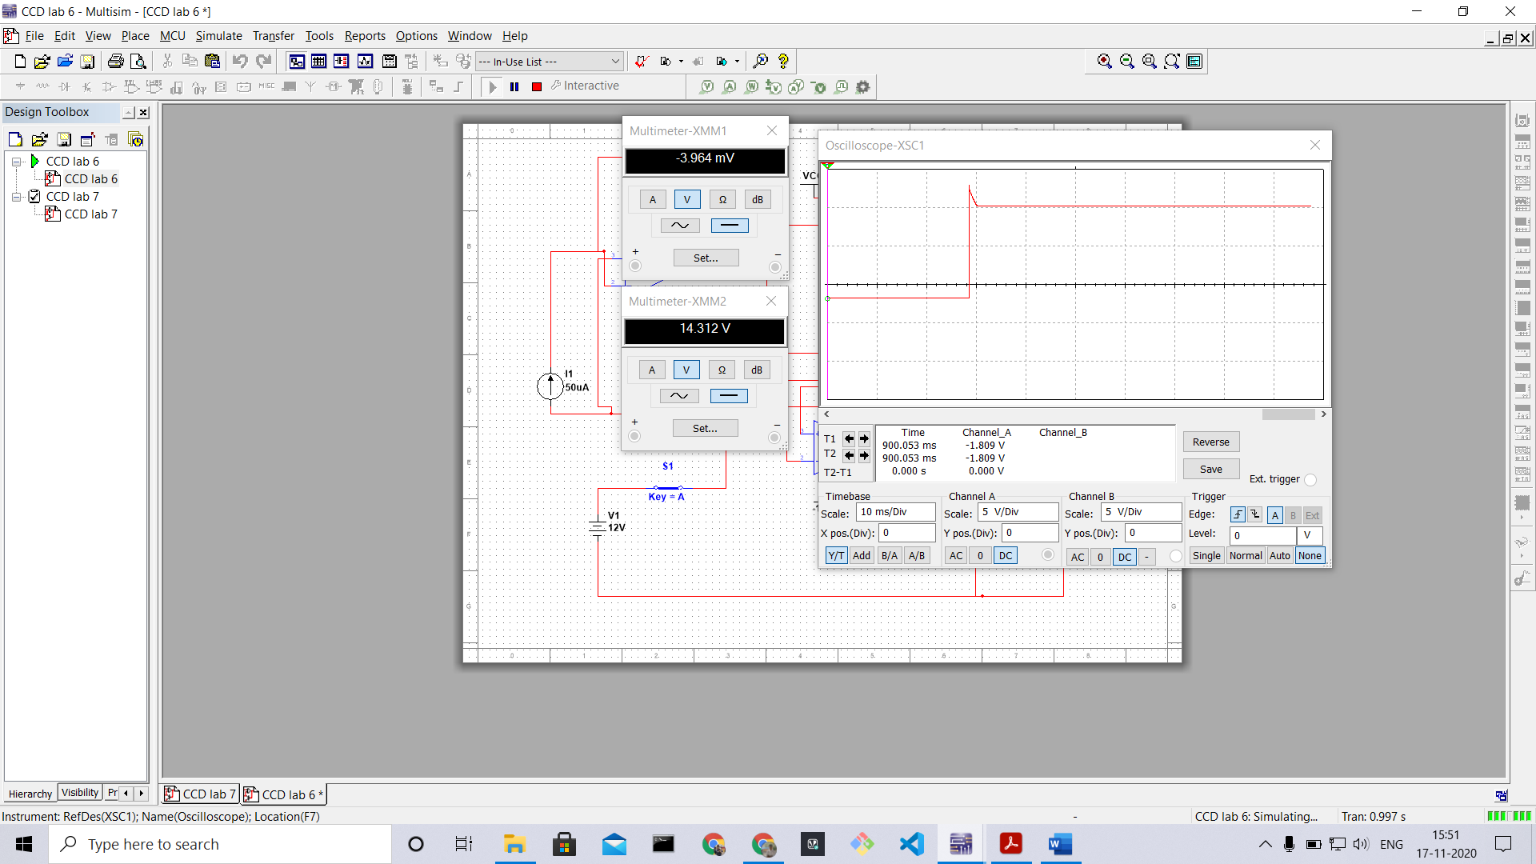

**Conclusion**: Designed and observed the circuit diagram of Sample and Hold Circuit along with its working, output voltages and its plots.